System Monitoring Tools Installation

=======================================================================

- Collectd Installation Steps:

- Install Dependencies
  - sudo apt-get install python
  - sudo apt-get install libcgi-session-perl
  - sudo apt-get install librrds-perl libjson-perl libhtml-parser-perl
  - sudo apt-get install git

- Install collectd
  - sudo apt-get install collectd

- Configure collectd
  - Edit the collectd.conf file in /etc/collectd directory
  - Add the following code snippet at the EOF

LoadPlugin network
<Plugin network>
<Server "{{Collectd-Server-IP}}" "25826">
</Server>
</Plugin>

  - Note: {{Collectd-Server-IP}} : IP of host machine where collectd will send it statistics
  - Save and exit the file

- Start Collectd Service
  - sudo serivce collectd start
  - To check status of collectd demon use following command
  - sudo serivce collectd status

- Collectd-web Installation Steps:

- Clone Collectd-web Git Repository on local machine

  - git clone "https://github.com/httpdss/collectd-web.git"

- Navigate to Collectd-Web folder

  - sudo chmod +x -R cgi-bin

- Edit and save the runserver.py file

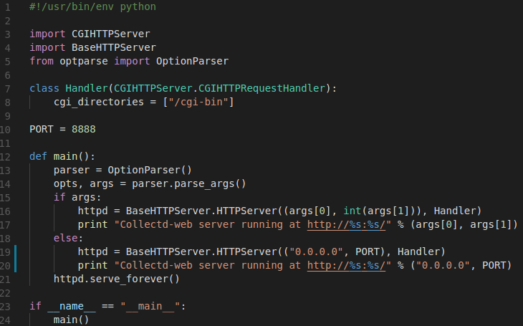
- Edit the IP to “0.0.0.0” in Line number 19 & 20, Save and exit

- Run the collectd-web server using following command

  - nohup ./runserver.py &

- Access the Collectd-web server using

  - http://{{Host-Machine-IP}}:8888

